

**IRS TRANSCRIPTS**



**TAX TRANSCRIPTS – IRS WAGE & INCOME VERIFICATION**

* Rep & Warranty indemnification from Freddie Mac and Fannie Mae
* Tax transcripts for loan origination are fulfilled 70% faster, are 100% accurate, and offered for a fraction of the cost of traditional methods
* Proprietary and direct connection with the IRS to retrieve accurate and reliable data

**IVES vs. Halcyon**

CHEAPER

FASTER

BETTER



|  |  |  |
| --- | --- | --- |
| **FEATURES** | **IVES – 4506C** | **HALCYON TAX TRANSCRIPTS** |
| Turnaround Time | Industry Average Days/Weeks | Minutes / Days |
| Cost | Total Cost Over $41 | **Per Loan** fee (saving 75% per loan) |
| Multiple Borrowers | Additional Cost per Borrower | No Additional Cost |
| Multiple Years in the Past | Additional Cost Each Year | No Additional Cost |
| Data Errors | Additional Cost | No Additional Cost |
| Multiple Years in the Future | No | Yes – Up to 3 Years in the Future |
| Data for all IRS Forms | No | Yes |
| Digitized Data (JSON) | No | Yes, Data that can be mapped into  an Income Calculator |
| Pre-Authorization | No | Yes, Free |
| Additional Transcript Pulls | No | Yes, Free |

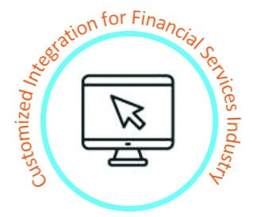

**INFORMATION: info@halcyonsw.com WEBSITE: www.halcyonsw.com**